Road to Nowhere
by Pauline O’Carolan

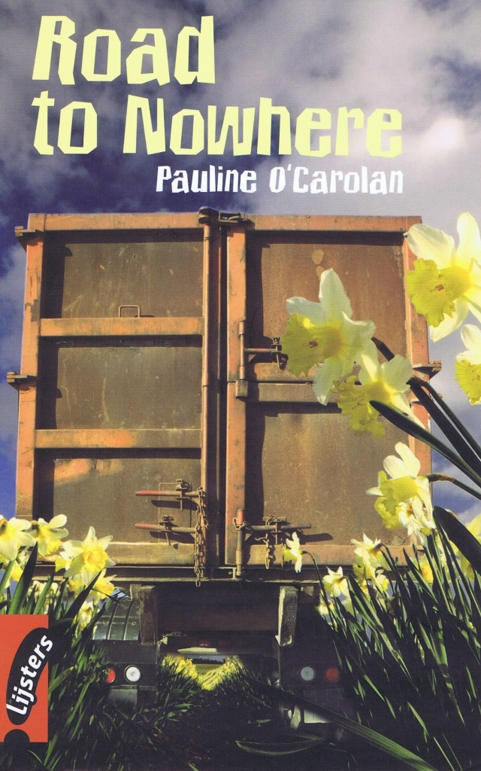

Assignments

Before Reading
- Describe what you see in the picture on the front cover of Road to Nowhere.

- The flowers that you see in this picture are the national emblem of Wales.
Now see if you can match the other parts of the United Kingdom with their emblems.
 | part of UK |  | emblem
A | England | I | thistle
B | Scotland | II | shamrock
C | Northern Ireland | III | rose

A = | B = | C =

- Look at the back cover of Road to Nowhere.
A What do you think is inside what you see in the picture?
B What does the word ruthless mean? Choose from:
I greedy II foreign III powerful IV showing no mercy
A
B

While Reading

Chapter 1 In a trap

- Where were Maxim and Maria hiding?

- 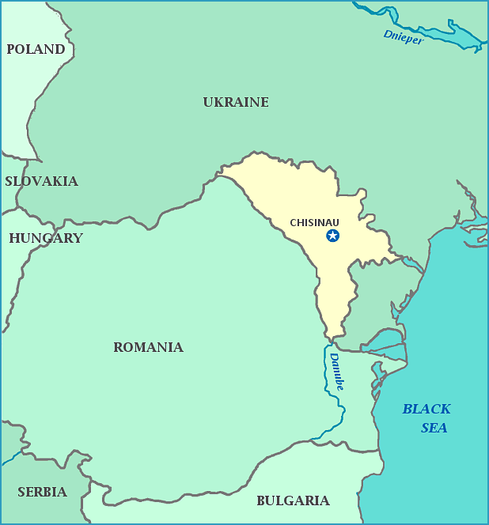What country did they and the others come from?

3 Where were they hoping to go?

4 What was the trap that Maxim was thinking about?

5 A Who were the sixteen people that were arrested that day?
B What had happened to make this arrest?
A
B

6 Nick’s father was a dairy farmer.
Write down at least three dairy products.

7 A When did Mr Bennett say ‘The Bennnetts don’t go abroad’?
B What does to go abroad mean?
A
B
8 Why did Nick say that he did not need to do any homework anymore?

9 Nick put on Wellington boots. What are Wellington boots?

10 Wellington boots (or: wellies) are called after the Duke of Wellington, who beat Napoleon Bonaparte in the Battle of Waterloo.
Below you see a list of people who invented certain objects and had these objects
named after them.
Match the objects with their inventors.

 | inventor |  | object
A | László Bíró | I | safety razor
B | Samuel Colt | II | vacuum cleaner
C | King Camp Gillette | III | waterproof raincoat
D | William Henry Hoover | IV | two slices of bread on top of each other
E | Jules Léotard | V | balloon airship
F | Charles Mackintosh | VI | revolver and other fire-arms
G | the Earl of Sandwich | VII | pen using ink cartridges
H | Ferdinand von Zeppelin | VIII | tight suit (originally for trapeze artists)

A = | B = | C = | D = | E = | F = | G = | H =

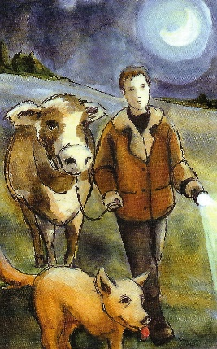

11 A Who is who in the picture on page 9?
B What is special about the dog?
A
B

12 What did Nick see when he went down to the beach?

13 A What did Mr Mason say that he was going to do?
B What was he really going to do?
A
B

Chapter 2 Not our problem

- What did Nick see from the top of the cliff?

- What did Mr Stone tell the group of Moldovans?

- Why were Maxim and Maria separated?

- After what Nick told his father he said ‘Not our problem’. Why did Nick’s father not want anything to with it?

- What do you think Nick should do now?

- Below you see a map of the area in which Road to Nowhere is set.

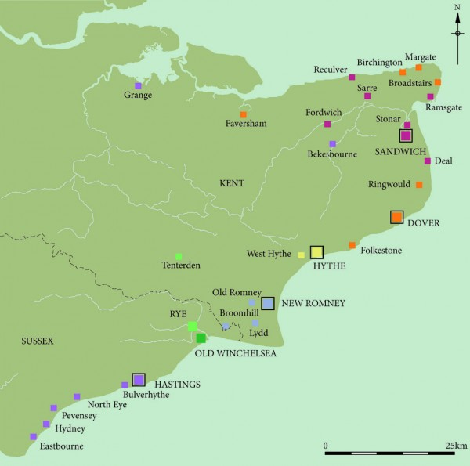A What part of England do you see?

B The most important towns on the map are known as the cinq ports, and were famous for smuggling goods to and from centuries ago.
Do you know how cinq ports translates from French into English?

C The cinq ports are the ones with the bigger squares. Write them down below.

A
B
C

Chapter 3 The face at the window

- 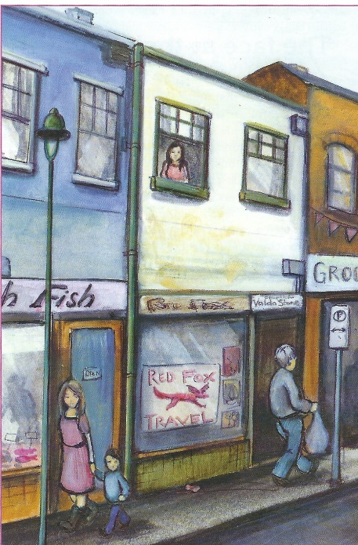What three shops do you see in the picture on page 17?

- Why did Nick enter ‘Red Fox Travel’?

3 A What was strange about the brochures in
‘Red Fox Travel’?
B What was wrong about the woman in
‘Red Fox Travel’?
A
B

4 Why was Maria too sad for tears?

5 When did Mrs Bennett tell Nick that some people should not have children?

6 Why did Mr Bennett think school was not important for Nick and that he could forget
about going to university?

- Did Mrs Bennett agree with her husband? Explain your answer.

- What was the other job that Nick had to do for Mr Stone?

- Mr Bennett wanted Nick to follow in his footsteps by eventually taking over the farm.
A Would you like to do the same job as your parents? Explain your answer.
B What would be your ideal future job?
C What would be your ideal holiday job?
A
B
C

Chapter 4 On Bluebell Farm

1 A Who was the owner of Bluebell Farm?
B Was it still a dairy farm? Explain your answer.
A
B

2 What were the caravans on Bluebell Farm probably used for?

3 A What was the van doing on Bluebell Farm?
B Who was the man in the blue coat driving it?
A
B

4 A Who was the girl in the window over the travel agency?
B Why was she there?
A
B

5 What had just happened in the picture on page 23?
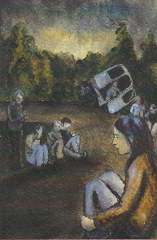

6 Why did Nick need a phone box to call an ambulance?

7 How could Nick help Maxim?

8 A What had happened when the ambulance arrived?
B Why was that?
A
B

9 Look at your answer to Question 5 of Chapter 2.
Was this what Nick did at the end of Chapter 4?

YES | NO

Chapter 5 A visit from Mr Mason

- Why were Nick and his father not talking during the milking of the cows?

- Why did Mr Mason quickly drop Nick’s arm?

- Mr and Mrs Bennett seemed to believe Mr Mason’s story.
How did this become clear?
Fill in the gaps.
Mr Bennett interrupted his son by saying ‘……………………………………………..…… (A).’

and Mrs Bennett invited Mr Mason ………………………………………………………..… (B).

- Do you think the pie that Mrs Bennett served was savoury or sweet?
Circle the correct answer.
SAVOURY | SWEET

- What did Mr Mason suggest to ‘help Mr Bennett’s business become more profitable’?
Fill in the gaps.
He suggested that Mr Bennett ……………………………………………………………….. (A).

The workers could ………………………………………………………………………… (B) and

Mrs Bennet could ……………………………………………………………………………… (C).

- Why did Nick call his father a coward?

7 A Who was the maid that was working for the Stones?
B How did she try to improve her English?
A
B

Chapter 6 Stone

- What was the reason that the school bus hit the parking sign at the side of the road?

- What was the reason Maria stopped running away?

- What did the sign ‘Proprietor Valda Stone’ mean? Circle A, B, or C.
A | That Valda Stone rented the shop
B | That Valda Stone owned the shop
C | That Valda Stone lived in the shop

- Why did Nick dress in black when he left the house that night?

- When Nick had found Maxim he saw that his arm was in a plaster cast. What had
caused this?

- What had happened to Maria and Maxim’s parents?

- What had Uncle Ivan done after that?

- Have a look at Question 2 again and give a different answer.

- Why were the men in the barn going to be replaced by a new group and sent back to
France?

- Why did Maxim leave the barn with Nick?

- Why did Nick need Maxim to go with him?

- Why did Nick need the phone book?

Chapter 7 Finding Maria

- A What did Maxim want to do once he had found Maria?
B What was the reason for this?

- Did Nick have a navigation system in his mother’s car? Explain your answer.

- Why had Maria not run away from the Stones?

- Why could Nick, Maxim and Maria not get back to the car?

5 A Who managed to escape from Hadley Hall?
B How did they do this?
C What did the third youngster do to make this possible?
A
B
C

6 True or False? Inspector Watkins and Sergeant Hollis were very helpful.
TRUE | FALSE

- Why had the police left Maxim behind?

- What had caused the marks on Maria’s arms and legs?

- What useful information did Mr Bennett tell the inspector?

- What did Inspector Watkins want Mr Bennett to do?

11 Why did Mr Bennett find it difficult to do this at first?

Chapter 8 Caught in the net

- Why was Zip looking hopeful?

- Why did The Masons have no reason to hurt Maxim?

- What was Nick’s father testing?

- What had Mr Stone done to make it seem that he and Mr Mason were not using illegal
workers?

- Why do you think Zip had to stay at home with Mrs Bennett and Maria while Nick and
his father went to the top of the cliffs that night?

- What was the thing that Mr Bennett was most sorry about?

- Why was Maxim among the people in the boat that was leaving?

- Why did Valda Stone hold Maria in front of her?

- What is happening in the picture on page 49
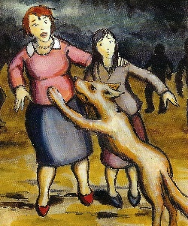

- Who were arrested that night?
Circle A, B, C, or D.
A | Rod Stone, Valda Stone, Fred Mason
B | Rod Stone, Fred Mason, Jackie Mason
C | Fred Mason, Jackie Mason, Valda Stone
D | Fred and Jacky Mason, Rod and Valda Stone

- What will happen to Maxim and Maria?
After Reading

1 Maxim and Maria had fled their country for the reason that you now know.
Over the last few years many migrants have tried to get away from their countries.

Below you can read a news item from BBC’s Newsround about the migration problem.
Read the text and answer the questions.

Each year thousands of men, women and children attempt a dangerous journey across the Mediterranean Sea to Europe.
Many of them are trying to escape poverty and war in their home countries.
But the journey is very dangerous and hundreds of people have died trying to reach Europe.

Why is the journey so unsafe?
Criminal gangs pack too many people into small boats, which leak and often sink. There's nobody to make sure the journey is safe.
The unsafe boats mean people have lost their lives at sea.

Why do migrants risk the journey?
The United Nations says 13,500 migrants have been rescued trying to reach Europe so far this year.
Around 35,000 migrants have arrived from Africa in 2015.
On 18 April 2016 a boat carrying up to 900 people sank. Authorities say 28 people were rescued; but many more died.
European leaders are trying to work out what to do.

Where are the migrants from?
Most migrants travelling to Italy are from Eritrea, Mali and Nigeria. They travel through Africa to Libya.
From Libya they board boats, many of which are not safe, and head to Italy.
There are also a huge number of migrants trying to reach Europe from Syria, trying to escape a civil war in their own country.

A What are the two reasons why people flee their country according to this news
item?
B Who are to blame for the many people that were drowned trying to cross the
sea?
C What is the reason that so many people have drowned?
D What is a civil war?

A
B
C
D

2 Some European countries welcome the migrants but others make it difficult for them to
enter their country.
What is your opinion about this?

